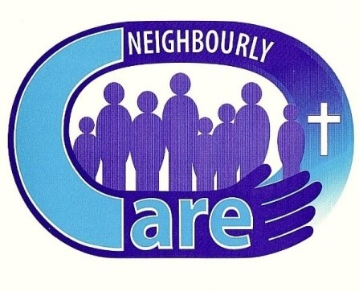
Neighbourly Care
Gift Aid Declaration

Through Gift Aid your donation is worth 25% more
Using Gift Aid means that we get an extra 25% from HMRC, helping your donation go further.
This means that £100 can be turned into £125, just fill out the form below and send it to us by post or email – details at the bottom of the form. Imagine what a difference that could make, and there is no extra cost to you!
If you have any questions about Gift Aid, please contact us and we will be happy to help
GIFT AID DECLARATION
 | Title: |  |  |  | Forename(s):
 |  |  |  | Surname:
 |  |  |  | Address:
 |  |  |  | Postcode:
 |  |  |  | Tel No:
 |  |  |  | Email:
Please treat as Gift Aid donations all donations made to Neighbourly Care.
 | Signature: |  |  |  |  |  |  | Date:

You must pay an amount of income tax and/or capital gains tax at least equal to the tax that the charity reclaims on your donations in the tax year (currently 25p for each £1 you give).
You can cancel this declaration at any time by notifying the charity.
If in the future your circumstances change and you no longer pay tax on your income and capital gains equal to the tax that the charity reclaims, you can cancel your declaration.
If you pay tax at the higher rate you can claim further tax relief in your Self- Assessment tax return.
If you are unsure whether your donations qualify for Gift Aid tax relief, ask the charity. Or ask your local tax office for leaflet IR 65.
Please notify the charity if you change your name or address.

Neighbourly Care in Hassocks, Burgess Hill and District - Registered Charity No 1127099
Neighbourly Care, C/O Centre Management Office, Market Place, Shopping Centre, Burgess Hill, RH15 9NP
Tel: 07876 066368 - email: neighbourlycare@outlook.com - www.neighbourlycare.co.uk

